**NAME: TEH YEE XIN**

**MATRIC NO: 278070**

**STIA1123 Programming 2 – Group I**

**Exercise 1.2 – Oriented Object Programing**

|  |
| --- |
| Cattle |
| - breed: String  - color: String  - countryOfOrigin: String  - uses: String |
| + setBreed(breed : String): void  + setColor(color : String): void  + setCountryOfOrigin(countryOfOrigin : String): void  + setUses(uses : String): void  + getBreed(): String  + getColor(): String  + getCountryOfOrigin(): String  + getUses(): String  + eat(): void  + sleep(): void  + walk(): void |

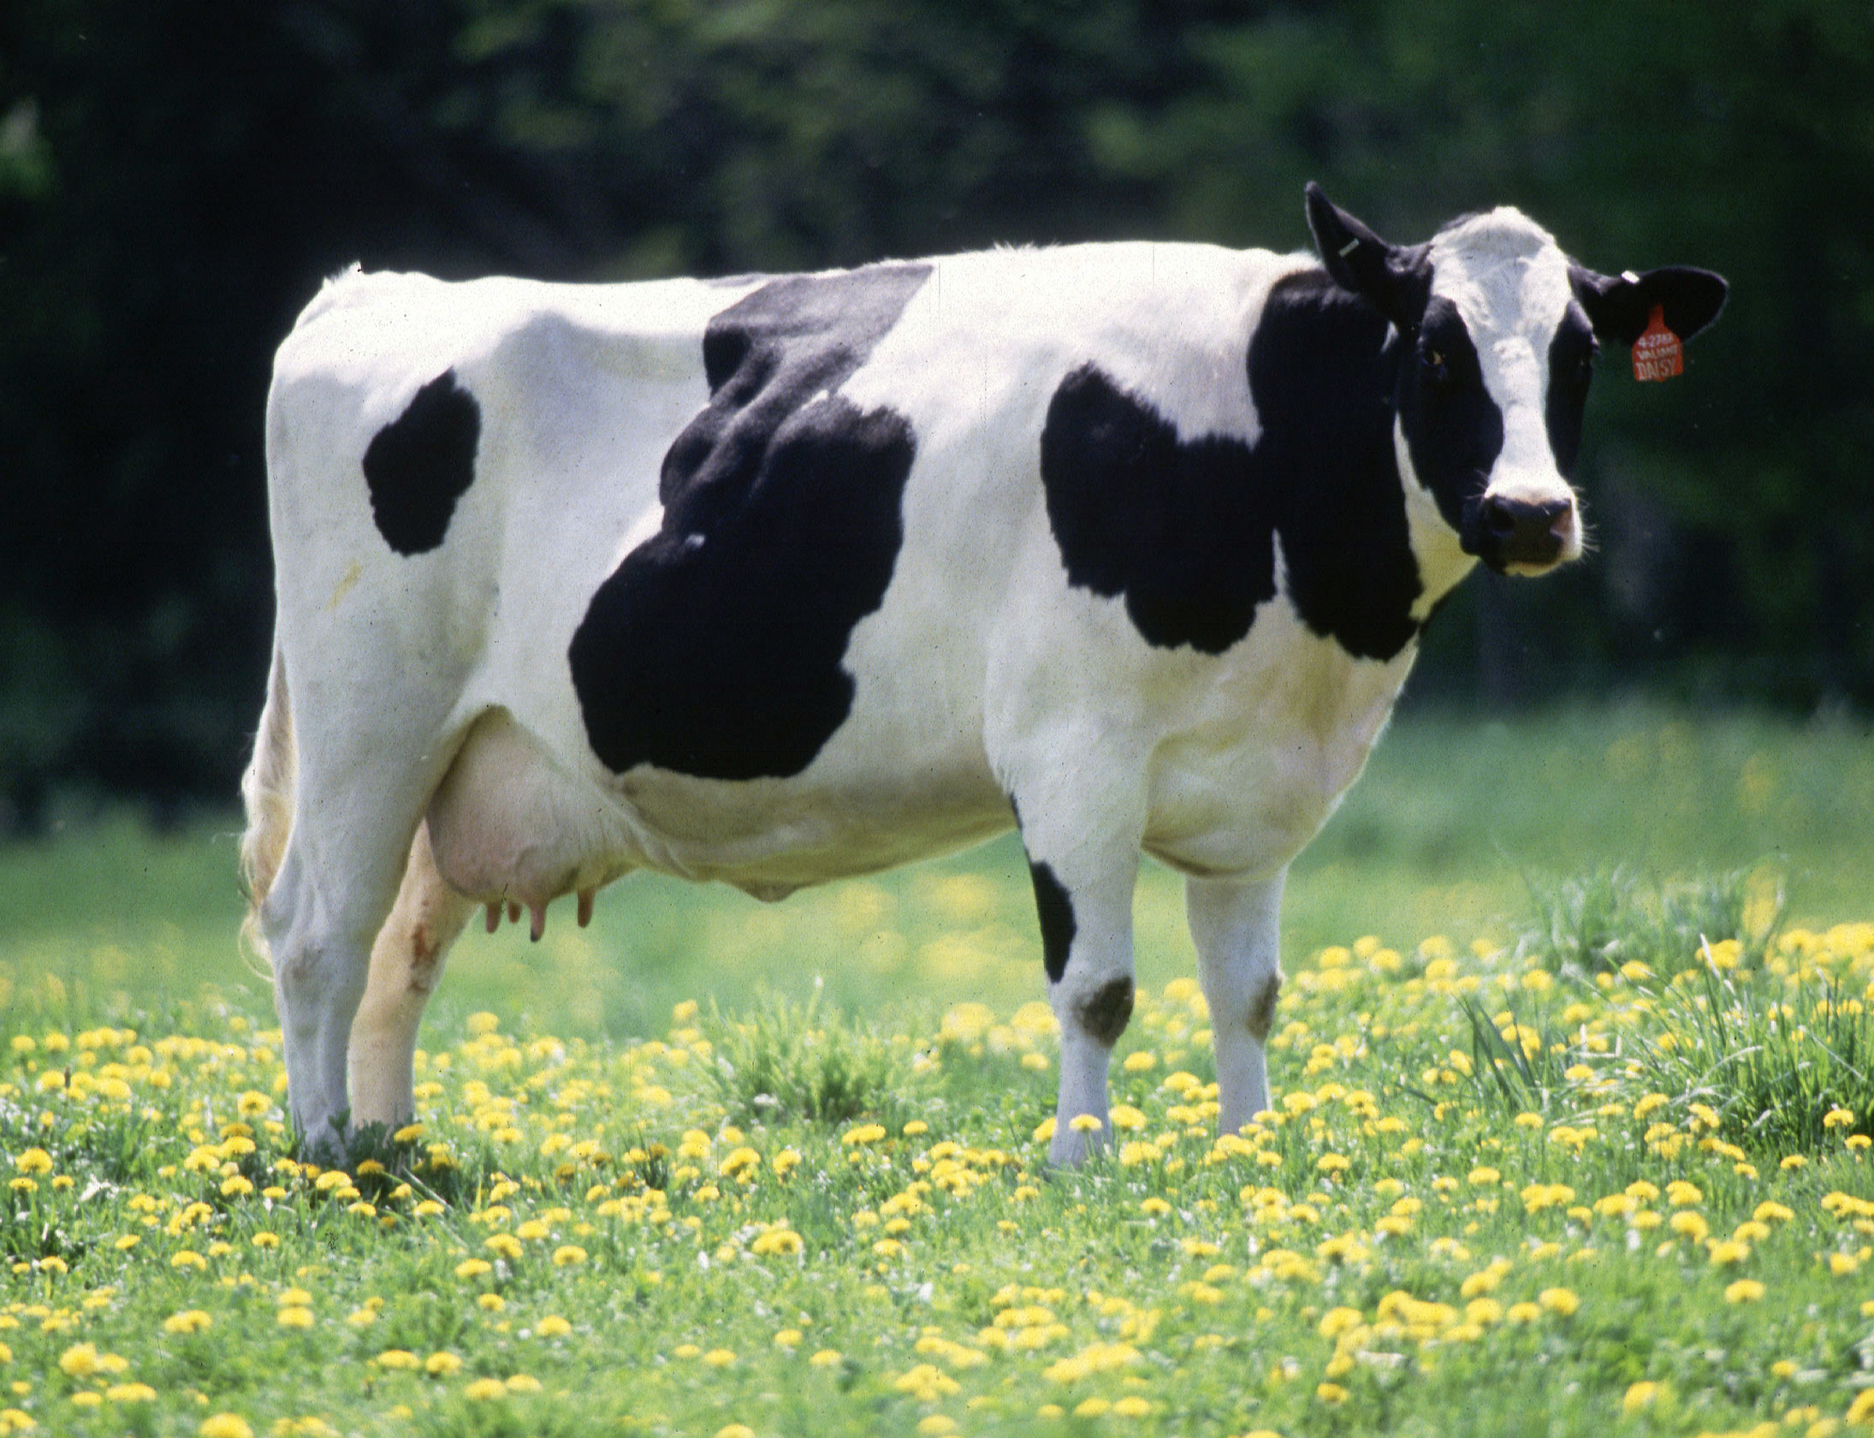 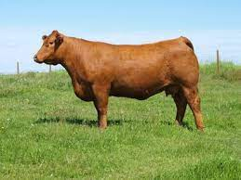 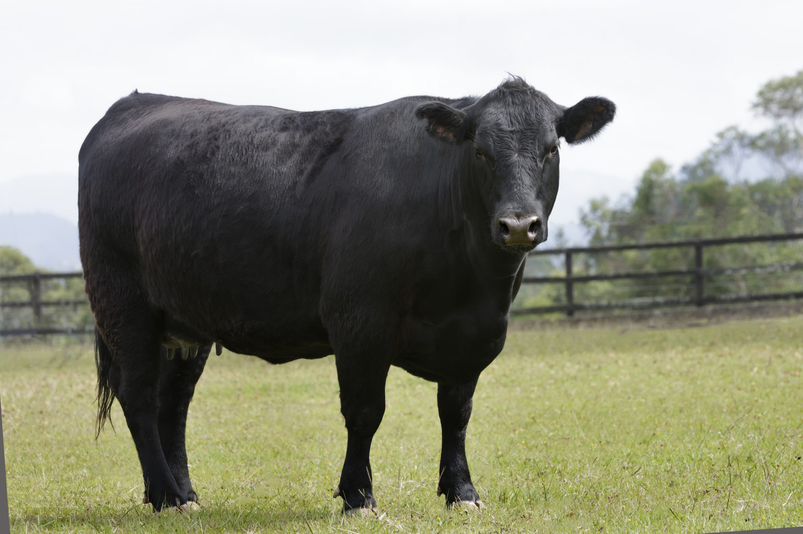

Breed: Holstein Friesians cattle

Color: Black and white

Country of origin:

Netherlands, Germany, Denmark, Austria, Switzerland, Belgium, France

Uses: Dairy

Breed: Agnus cattle

Color: Black

Country of origin: Scotland

Uses: Beef

Breed: Limousin cattle

Color: Gold

Country of origin: France

Uses: Crossbreeding

|  |
| --- |
| Smartphone |
| - brand: String  - color: String  - model: String  - screen size: double |
| + setBrand(breed : String): void  + setColor(color : String): void  + setModel(model : String): void  + setScreenSize(screenSize : double): void  + getBrand(): String  + getColor(): String  + getModel(): String  + getScreenSize(): double  + phone call(): void  + send message(): void  + playing game(): void |

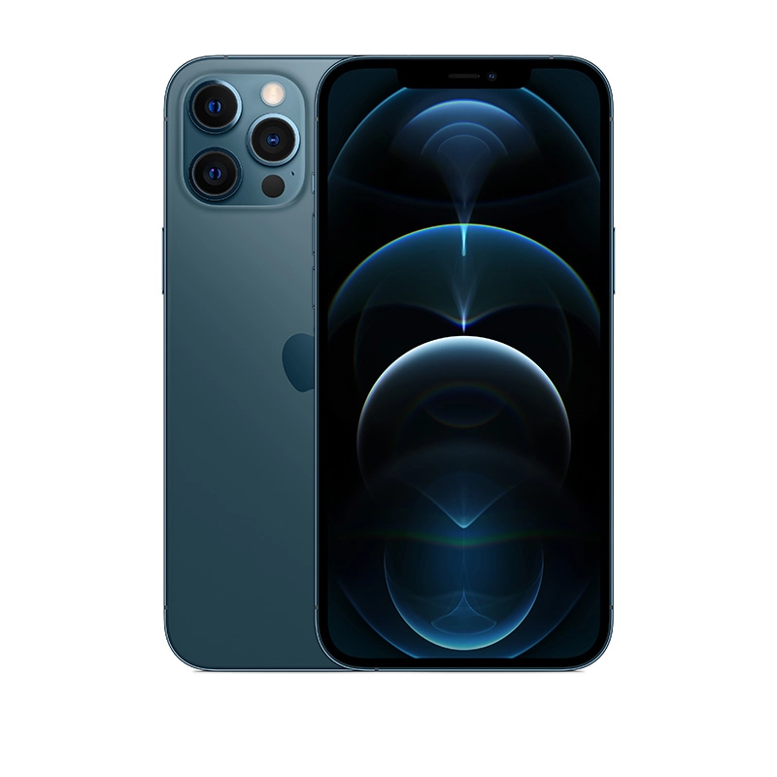 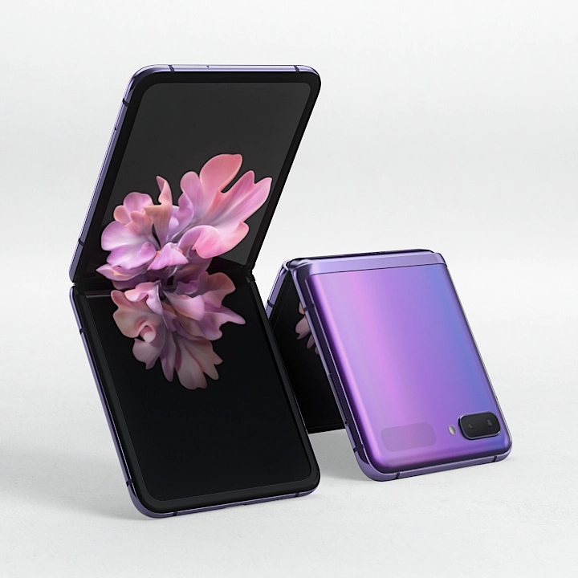 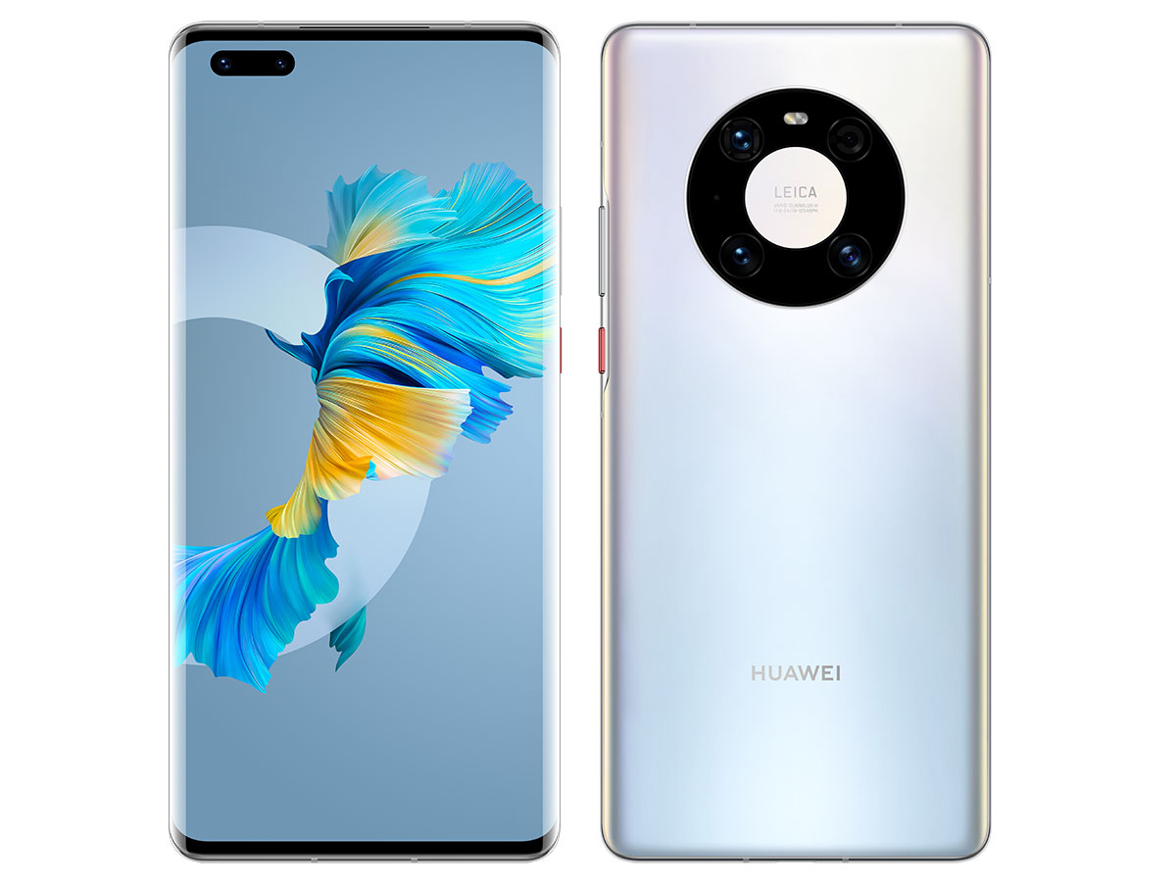

Brand: Huawei

Color: Mystic silver

Model: Huawei Mate 40 Pro

Screen size: 6.76”

Brand: Samsung

Color: Mirror purple

Model: Samsung Galaxy Z Flip

Screen size: 6.7”

Brand: Apple

Color: Pacific blue

Model: iPhone 12 Pro Max

Screen size: 6.7”

|  |
| --- |
| Multi Cooker |
| - brand: String  - model: String  - capacity: double  - potMaterial: String  - powerConsumption: int |
| + setBrand(breed : String): void  + setModel(model : String): void  + setCapacity(capacity : double): void  + setPotMaterial(potMaterial: String): void  + setPowerConsumption(powerConsumption: int): void  + getBrand(): String  + getModel(): String  + getCapacity(): double  + getPotMaterial(): String  + getPowerConsumption(): int  + cook rice(): void  + steam(): void  + boiling water(): void |

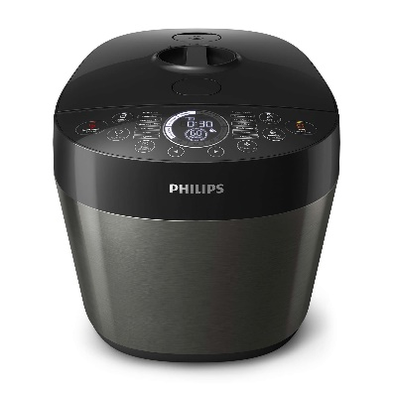 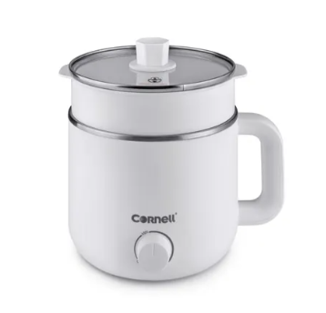 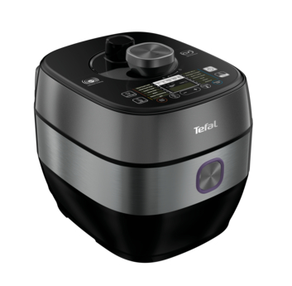

Brand: Tefal

Model: CY638D

Capacity: 5.0L

Pot material: Ceramic Power consumption: 1300W

Brand: Cornell

Model: CMC-S1500X

Capacity: 1.5L

Pot material: Stainless steel

Power consumption: 800W

Brand: Philip

Model: HD2145

Capacity: 6.0L

Pot material: Ceramic

Power consumption: 1000W

|  |
| --- |
| Laptop |
| - brand: String  - color: String  - model: String  - screen: String  - weight: double |
| + setBrand(breed : String): void  + setColor(color : String): void  + setModel(model : String): void  + setScreen(screen : String): void  + setWeight(screen : double): void  + getBrand(): String  + getColor(): String  + getModel(): String  + getScreen(): String  + getWeight(): double  + browser(): void  + watching videos(): void  + playing games(): void |

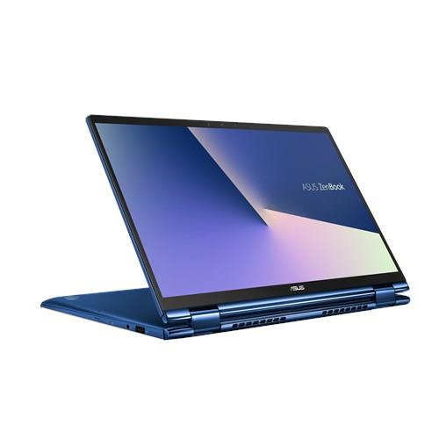 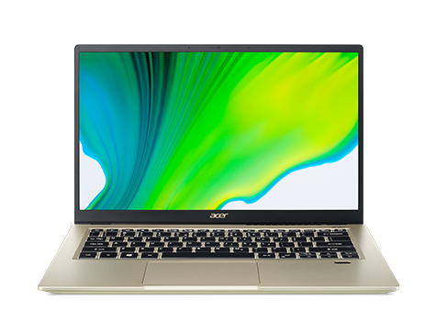 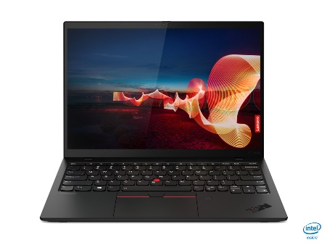

Brand: Lenovo

Color: Black

Model: ThinkPad X1 Nano

Screen: LED Backlight

Weight: 0.962kg

Brand: Acer

Color: Gold

Model: Swift 3X

Screen: FHD IPS screen

Weight: 1.37kg

Brand: Asus

Color: Pine grey

Model: ZenBook Flip 13

Screen: OLED HDR

Weight: 1.3kg

5.

|  |
| --- |
| Bear |
| - breed: String  - color: String  - genus: String |
| + setBreed(breed : String): void  + setColor(color : String): void  + setGenus(genus : String): void  + getBreed(): String  + getColor(): String  + getGenus(): String  + eat(): void  + sleep(): void  + crawl(): void |

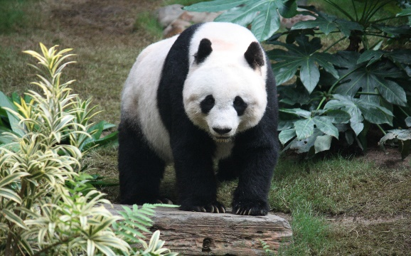 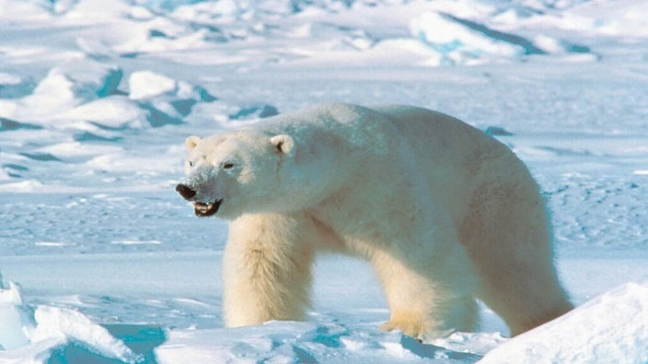 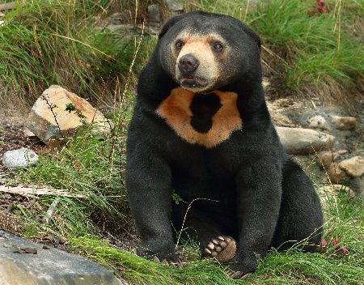

Breed: Sun Bear

Color: Black and orange

Genus: Helarctos

Breed: Polar Bear

Color: White

Genus: Ursus

Breed: Giant Panda

Color: Black and white

Genus: Ailuropoda